The Islamia University of Bahawalpur
Department of Information Technology
Faculty of Computing


SOFTWARE DESIGN DOCUMENT (SDD)
for
Online Complaint Monitoring System
Version 1.0

By
Student Name: Ariba Khalid
Roll No: S25BINFT7M04003
Session: Spring 2025 – 2027
Supervisor: Dr Dost Muhammad Khan
Bachelor of Science in Information Technology

Revision History

Date | Description | Author | Comments

Document Approval
The following Software Design Document (SDD) has been accepted and approved by the following:
Signature |  | Printed Name | Title | Date
 | .

Supervised by
Dr Dost Muhammad Khan

Signature______ _____

INTRODUCTION

Advent

the subsequent subsections of the software program requirements specifications (SDD) record ought to provide a outline of the entire SDD..

1.2 Motive
Online Complaint Monitoring System (OCMS) is designed to facilitate efficient management of user complaints in an online environment that is transparent and user friendly. Manual systems of complaint management lack efficiency and reliability as these are prone to errors. This system will help in computerizing the process, reducing physical interactions and streamlining the procedure for complainants and management alike. It will also help monitor and expedite timebound redressal of complaint by maintaining proper tracking and accountability. The system shall facilitate active interaction between users and management through a more effective and reliable mechanism for registering and resolving complaints.

1.3) Target audience
This Online Complaint Monitoring System is specifically designed for the students, teachers, administrative staff/employees of the institutions/organizations and the management authorities responsible for redressal of complaints. The system is user-friendly and easy to use for a person with basic computer knowledge. The system is also very beneficial for the organizations which are looking to mechanize their complaint handling process.

1.4) Scope
This Online Complaint Monitoring System is designed to register, track, manage and monitor the progress of complaints within an organisation. It allows users to lodge complaints at any time of the day and monitors the status of complaints until it is resolved. The system is multi-user enabled, capable of storing a large amount of data and generates statistics and reports for reference. This system can be implemented in schools, colleges, universities and other corporate organisations. Future enhancements will include mobile enabled version, email alert notifications, advanced analytics and etc. The system will automate the process of complaint management and enhance organisational efficiency and productivity through online enabled technology.

1.5) Definitions, Acronyms and Abbreviation
Term / Acronym | Full Form / Definition
SRS | Software Requirements Specification; a document that describes the functionalities, requirements, and constraints of the Online Complaint Monitoring System.
Online Complaint Monitoring System | A web-based application that allows users to submit, track, and manage complaints efficiently through an online platform.
PHP | Hypertext Preprocessor; a server-side scripting language used to develop the Online Complaint Monitoring System.
Web Application | A software application that runs on a web server and is accessed through a web browser for submitting and managing complaints.
Complaint | A formal report submitted by a user regarding an issue, problem, or concern within the organization.
User | Any individual such as a student, employee, or staff member who uses the system to submit and track complaints.
Admin | An authorized person responsible for managing complaints, users, and overall system operations.
Complaint Management | The process of receiving, reviewing, assigning, and resolving complaints within the system.
Dashboard | A web interface that displays summarized complaint data, status updates, and system information to users or administrators.
Database | A structured collection of data used to store user details, complaints, and system records.
Authentication | The process of verifying the identity of a user before granting access to the system.
Authorization | The process of granting permissions to users based on their roles (e.g., admin or user).
Status Tracking | A feature that allows users to monitor the progress of their submitted complaints.
Performance | The ability of the system to process complaints quickly and respond to user actions efficiently.
Security | Measures implemented to protect user data and prevent unauthorized access to the system.
Term / Acronym | Full Form / Definition
SRS | Software Requirements Specification; a document that describes the functionalities, requirements, and constraints of the Online Complaint Monitoring System.

2.SYSTEM ARCHITECTURE

2.1 Architectural Design

2.1.1 User Interface (UI) and User Experience (UX)
Our system provides an easy to use interface and makes it simple for the user to add and track complaints. We have made sure that the navigation, forms and the use of the dashboard is as user friendly as possible to ensure that all users with basic computer skills are able to make full use of the system and reduce errors during the complaint submission and monitoring process.

2.1.2 Backend Architecture
For our backend, we have implemented a robust architecture with PHP and MySQL, which efficiently manages all functionalities of the system such as storing and processing complaints, user registration, and system logic. The system is capable to function efficiently and is scalable for handling large amount or users and complaints at one time without any system crash or error and also communicates smoothly with our user-friendly interface.

2.1.3 Security
The system is designed to protect its users and their information through numerous security features. Many aspects of the system require authentication and/or authorization by registered users or admins before operations can be performed. Not only is user complaint information stored in the database securely, but all incoming data is also validated for basic security to prevent common attacks and to maintain the confidentiality and integrity of user provided information.

2.1.4 Search and Filtering
System search and filter features can be used to efficiently find users and administrator complaints and track their progress. Users can be searched by ID, category or status. When searching for users, complaints can be filtered and ordered by priority and progress. This allows for efficient and timely handling of complaints.

2.1.5 Overall Performance
Our system processes user requests and their related complaint information in a timely manner and with the utmost priority. You can always obtain current system information whenever you need it. Our module is light-weight and fully functional on your server allowing multiple users to simultaneously submit new requests or check the status of in progress or completed requests. The software was written using PHP and stores information in a MySQL database. The database queries in the software have been optimized using PHP to assure maximum reliability.
2.2) Decomposition Description

User Management Module
The module for user registration, login and management allows students, employees, teachers and other staff to create their own user accounts. The system has functions for student, employee/staff registration, user login (authentication) and management of user information including role and access rights. Users can update their information as necessary.

Complaint Submission Module
Online Complaint Form module allows your users to lodge complaints online with ease. A simple form is created where users can enter details such as the type of the complaint, description and date. Each complaint will be stored in the database with a unique ID to allow easy reference. Online submission of complaints simplifies the process and prevents errors that occur when manually filling up paperwork. This module is the core entry point of the system and all complaints are recorded and logged within.

Complaint Management Module
This module is mainly use to manage all complaints by admin. You can also view, edit, assign & resolve the complaints in this module. Admin can also change status of complaint from pending to in progress and from in progress to resolved. This module helps admin to organize the complains in efficient manner and admin will be able to handle them in proper time and also be accountable.

Tracking & Status Module
This adds a notification component allowing for status changes to notify the user. This feature saves a lot of headaches as users don’t have to contact the site for follow-ups, and shows users that you are going to handle their issues in a fair and expedient manner increasing overall user satisfaction.

Search & Filter Module
This module allows users and administrators to quickly search for specific complaints. It allows you to search for complaints based on the ID, category and user information. Filtering options enable sorting of complaints by status or date. This makes it very efficient to manage a large number of complaints. Easy access to information that you need is the main aim of this module.

Admin Dashboard Module
Admin monitoring activity gives a summary of system activities for the administrator. This component displays total complaints, total resolved cases and pending cases in the form of charts or statistics to facilitate prompt decision making. The dashboard is a central place for efficient management and supervision of the system.

Database Management Module
This module takes care of storing and retrieving all the data on the system. The data for all the user information, user complaints and system information is stored in the MySQL database in the form of tables and it ensures data normality and consistency. The stored data can be backed up and restored as required. This module is thus essential for the proper functioning of the system.

2.3) Format cause

2.3 User Interface and User Experience Requirements
2.3.1 Visual Design
The system design employs a clean and simple approach, which enables users to easily and clearly know how to use the system. The system incorporates proper color combination, font legibility, and layout organization. Icons and headings are implemented to lead the user through various system features. This avoids unnecessary confusion and facilitates the interaction of systems.

2.3.2 User Experience (UX)
The system is designed to be as user friendly as possible. You can go to any page you wish, lodge or track a complaint and generally get around the system without too much trouble. Helpful instructions and feedback messages are provided wherever necessary and the interface has been designed to be as user friendly and error free as possible.
2.3.3 Responsive Interface
Our system is fully responsive and can be accessed via Desktop, Tablet and Smart Phone with content and layout automatically adjusting to suit the screen size of the user. This means our system can be accessed at anytime and anywhere. You can access our system using your smart phone, tablet, computer and notebook with ease.
2.3.4 Security
The complaint system is secured using user authentication and role based access controls so only the correct users can perform the correct actions. Input validation on the website as well as on the server side for all database interactions ensures that data is checked and cleaned to prevent the misuse of sensitive complaint information.
2.3.5 Performance
Our system offers rapid response and high performance. System response to commands and processing of user requests are very fast. We have optimized database queries to rapidly extract information needed for reporting and statistics. The system can be set up to handle a large number of users at the same time.
2.3.6 Search and Filtering
All the information is easily accessible with search and filter capabilities. Users can search for specific complaints by their complaint IDs, categories, or statuses. We have also included filters for priority and status to organize the information for our users and administrators to increase productivity and save time.
2.3.7 Integration with Third-Party Tools
Our system can also integrate with existing 3rd party applications and systems such as email and SMS notification providers. This will inform the complainer of the status of the complaint. The system can also integrate with reporting tools to help you better analyse complaints and trends.

Class diagram
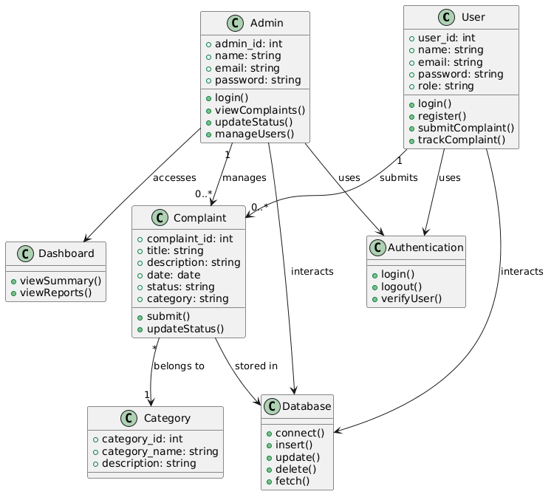

Activity diagram
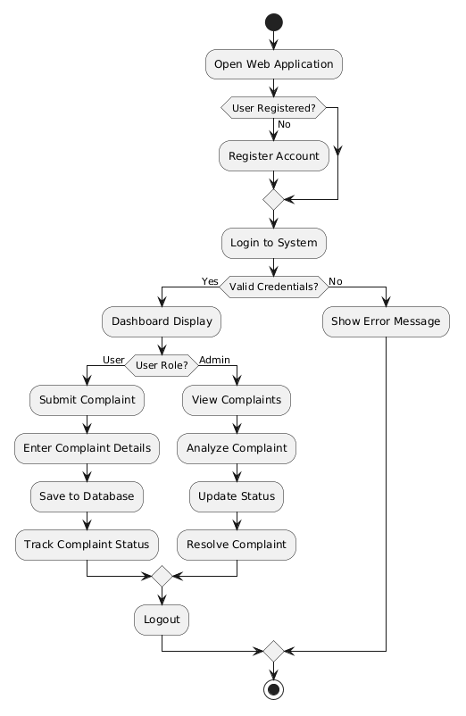

Data flow diagram (0 level)
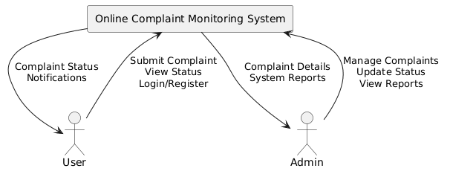

ER-diagram
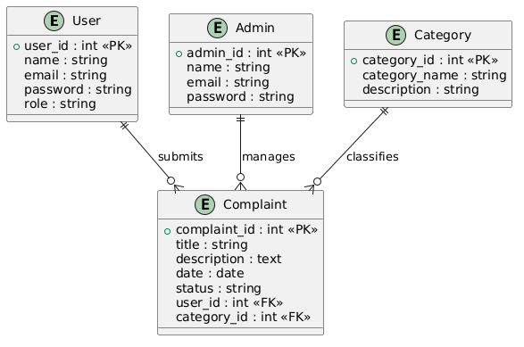

3.DATA DESIGN

3.2)Data Dictionary
Data Element | Type | Format / Size | Description
complaint_id | Integer | 4 bytes | Unique identifier for each complaint submitted in the system.
complaint_title | String | 100 chars | Title or subject of the complaint.
user_id | Integer | 4 bytes | Identifier for the user who submitted the complaint.
admin_id | Integer | 4 bytes | Identifier for the admin handling the complaint.
category_id | Integer | 4 bytes | Identifier for the category of the complaint (e.g., academic, facility).
description | String / Text | Variable | Detailed explanation of the complaint.
status | String | 50 chars | Current status of the complaint (e.g., pending, in progress, resolved).
submission_date | DateTime | ISO 8601 | Date and time when the complaint was submitted.
resolution_date | DateTime | ISO 8601 | Date and time when the complaint was resolved.
priority | String | 20 chars | Priority level of the complaint (e.g., low, medium, high).
notifications | JSON / String | Variable | Configuration for alerts/updates for users (e.g., email, dashboard).
report_id | Integer | 4 bytes | Unique identifier for generated complaint reports.
report_type | String | 50 chars | Type of report (e.g., pending complaints, resolved complaints).
report_content | JSON / String | Variable | Detailed content of the report including complaint metrics.
alert_id | Integer | 4 bytes | Unique identifier for system alerts related to complaints.
alert_type | String | 50 chars | Type of alert (e.g., overdue complaint, high-priority complaint).
timestamp | DateTime | ISO 8601 | Time at which an alert or status change was recorded.
Data Element | Type | Format / Size | Description
complaint_id | Integer | 4 bytes | Unique identifier for each complaint submitted in the system.

4.HUMAN INTERFACE DESIGN

4.1 Overview of User Interface
The user interface of the Online Complaint Monitoring System is made simple, intuitive and user-friendly for easier navigation for students, employees and staff. Icons, headings and colors are used to highlight important elements to avoid mistakes and to assist users in navigating properly. The system has simple menus, forms and tabs for student’s complaint submission and tracking. The interaction with the system does not require any additional training for students, employees and staff. The admin interface comes with more options to manage complaints, users and generate reports.

Screen Images
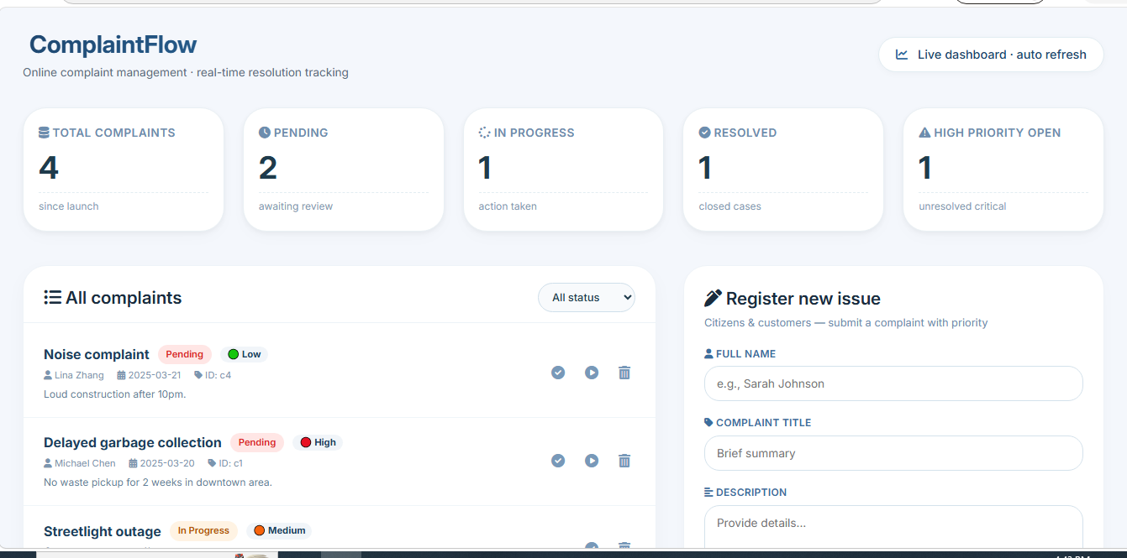

The design will be contemporary to this website

5. REQUIREMENTS MATRIX
Req. ID | Requirement Description | Type | Priority | Module/Feature | Verification Method
FR-1 | System shall allow users to register, login, and manage their accounts. | Functional | High | User Management | Test user registration, login/logout, and profile updates
FR-2 | System shall allow users to submit complaints with details such as title, category, and description. | Functional | High | Complaint Submission | Test complaint creation and data storage
FR-3 | System shall allow users to track the status of their complaints in real-time. | Functional | High | Complaint Tracking | Verify status updates and user visibility
FR-4 | System shall allow admin to view, manage, and update complaint status. | Functional | High | Complaint Management | Test admin actions like updating and resolving complaints
FR-5 | System shall store user data, complaints, and system logs in a database. | Functional | High | Data Management / Logging | Verify data storage and retrieval from database
FR-6 | System shall provide search and filtering options for complaints. | Functional | Medium | Search and Filtering | Test search by complaint ID, category, and status
FR-7 | System shall send notifications to users about complaint status updates. | Functional | High | Notification / Alerts | Simulate status change and check notifications
FR-8 | System shall allow admin to generate reports on complaints (e.g., resolved, pending). | Functional | Medium | Reporting | Verify report accuracy and data representation
NFR-1 | System shall provide a responsive UI for desktops, tablets, and mobile devices. | Non-Functional | High | User Interface | Test system on different devices and screen sizes
NFR-2 | System shall process user requests and load data with minimal delay. | Non-Functional | High | Performance | Measure system response time and loading speed
NFR-3 | System shall ensure secure authentication and protect user data. | Non-Functional | High | Security | Test login security and data protection mechanisms
NFR-4 | System shall support multiple users accessing the system simultaneously. | Non-Functional | Medium | Backend / System | Perform load testing with concurrent users
NFR-5 | System shall maintain logs of user activities and complaint updates. | Non-Functional | Medium | Data Management / Logging | Verify logs for accuracy and completeness
NFR-6 | System shall allow integration with email or SMS services for notifications. | Non-Functional | Low | Integration | Test sending notifications via external services

